SIRS-StarDrive
Infrastructure

All machines will be running a Debian distro.
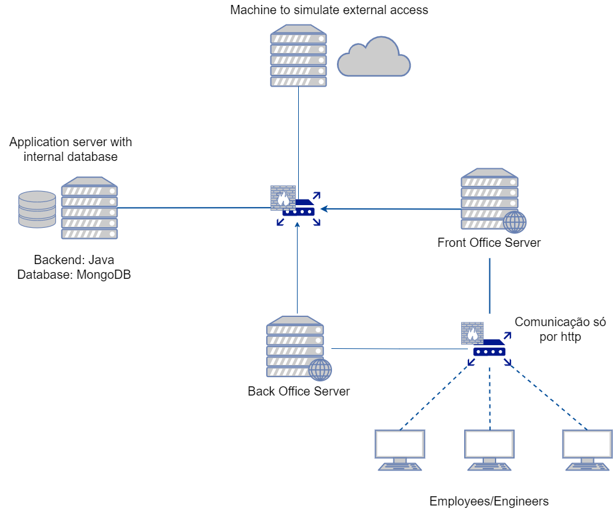
Internal Networks:
sw-1: Application and RouterBack
sw-2: BackOffice and RouterBack
sw-3: FrontOffice and RouterBack
sw-4: Front Office and Clients
sw-5: BackOffice and Engineers

Application:
ens0p3:
ip: 192.168.0.1

FrontOffice:
ens0p3:
ip: 192.168.1.2
ens0p8:
ip: 10.0.1.2 (front.star.drive.pt)

BackOffice:
ens0p3:
ip: 192.168.2.2
ens0p8:
ip: 10.0.2.2 (back.star.drive.pt)

RouterBack:
ens0p3:
ip: 192.168.0.254
ens0p8:
ip: 192.168.1.254
ens0p9:
ip: 192.168.2.254
ens0p10: NAT

RouterFront:
ens0p3:
ip: 10.0.1.254
ens0p8:
ip: 10.0.2.254
ens0p9:
ip: 10.0.3.254

Server communications
The firewall between the employees/engineers and the Front office server and back office server will only allow http requests from the employees
The second firewall will only allow http requests from the front/back office servers and the application server with internal database and http request from the application server with internal database and the external network, the back office will also be allowed to make http request to the external network.
Security challenge
(i) There are some concerns regarding access to the control system of StarDrive. Only authenticated engineers can manage the actuators of the factory. Also, every access to the actuators needs to be stored for audit purposes.

